AP Statistics 4th Quarter Project (2018)

 | Due dates | Maximum Points
I. Project Proposal | April 4 (Wednesday) | 15
II. Project Data & Analysis Design | April 25 (Wednesday) | 15
III. Team PowerPoint Presentation | May 7 (Monday) | 30
IV. Individual Written Report  [Final Exam pending administrative approval.] | May 9 (Wednesday) | 40
1. Penalty : Use of existing data  2. Penalty : Change of original Proposal  3. Penalty : non-aggregated data only |  | -10  -10  -5

I. Proposal Requirements:
[15 pts] The proposal is a one page formal (not hand-written) document that summarizes your team’s brainstorming and discussion on selecting a project topic. Your proposal must include and discuss the following in an outline format:
- The specific question your project will answer,
- why that question is proposed,
- a few alternatives for possible data collection approaches, and
- statistical techniques you might use to analyze your data and help answer your question.
Finally, all team members must sign the proposal. You must also list the preferred email address I should use to contact the team leader. Before turning in your proposal, compare your thinking to the project scoring rubric (handout) and the American Statistical Association Project Competition paper, What Is a Statistical Project? (see reverse). I will return your proposal with comments within a week.

II. Data Collection and Analysis Design Requirements for both Individual and Aggregated Team Data:
[15 pts] This 1-2 page team paper updates any changes from the original proposal submission, describes in detail the data collection plan, and describes in detail the specific analysis techniques (methods) and tools (software) that will be used to analyze the data. IF your team is using pre-existing data in your project (10 point penalty) then you must write a critique of the data collection method used by those who collected the data. You may attach any example data collection material (survey, tally sheets, etc.) or illustrative graphs that help describe your plans. Before the team captain turns in this requirement document, re-read and follow guidance on the project scoring rubric (handout) and The American Statistical Association Project Competition paper, What Is a Statistical Project? (see reverse). I will return your Data Collection and Analysis Design with my comments within a week.

III. The Full-Team Presentation
[30 pts] 5-15 slides, max 15 minute class presentation. Scoring is according to the attached page.

IV. The Individual Written Report
Each student has an individual written report (maximum 2-pages) must include sections for:
- [20 pts] analysis of data you collected individually [see Scoring Rubric ASA Project],
- [10 pts] analysis of data that the team aggregated, [see Scoring Rubric ASA Project] and
- [10 pts] a comparison of the two analyses.
II. Team Data Collection and Analysis Design Requirements using Aggregated Team Data:

Team Members: ___________ ___________ ___________ ___________ [Captain]

[ Team Captain must submit this completed form to Mr. Meinzen by due date]

Timeliness: ____ 5 points
Collection: ____ 5 points
Analysis: ____ 5 points

Describes in detail the data collection plan,
• Tell me exactly how your team will collect your data. Your collection plan should have enough detail so I could use what is written to collect the data without your help or can give it to another team as a redundant check. Think: recipe for baking a cake. Note any discrepancies between individual collection of data and rest of team.

Describes in detail the specific analysis techniques (methods) and tools (software)
• Your team analysis requirements should tell me exactly what you will do with your aggregated data once collected and how you will display its meaning. I should be able to take your data with your analysis requirements and do the analysis exactly how you intended.

III. Team Presentation

Team Members: ___________ ___________ ___________ ___________ [Captain]

[Team captain is to present this rubric to Mr. Meinzen before the team start your presentation.]

Project Question:

__________________________________________________________

(5) _____ Timeliness: Your Presentation file is due on or before: May 7th. By this due date, your final presentation must be saved to the team captain’s H:\ drive saved as “AP Statistics 4th Quarter Project.ppt”

(5) ______Length: Must not exceed 15 minutes

(5) ______Presenters: All team members must discuss some aspect of the project during presentation. Missing team members are: ________________________________

(5) ______Format: Must use PowerPoint and must engage the entire class in presentation.

(10) _____Content: Describe the specific question your team investigated, what you did to complete your project plan AND the results of your analysis (what did your analysis reveal?). Your conclusion must explain what you would have done differently if you could re-do the project and what recommendation you have for extending your project if you could have 6 more months.

Score: ______/30

Notes

Start time:

End time:

IV. Sample Rubric for the Individual Written Report

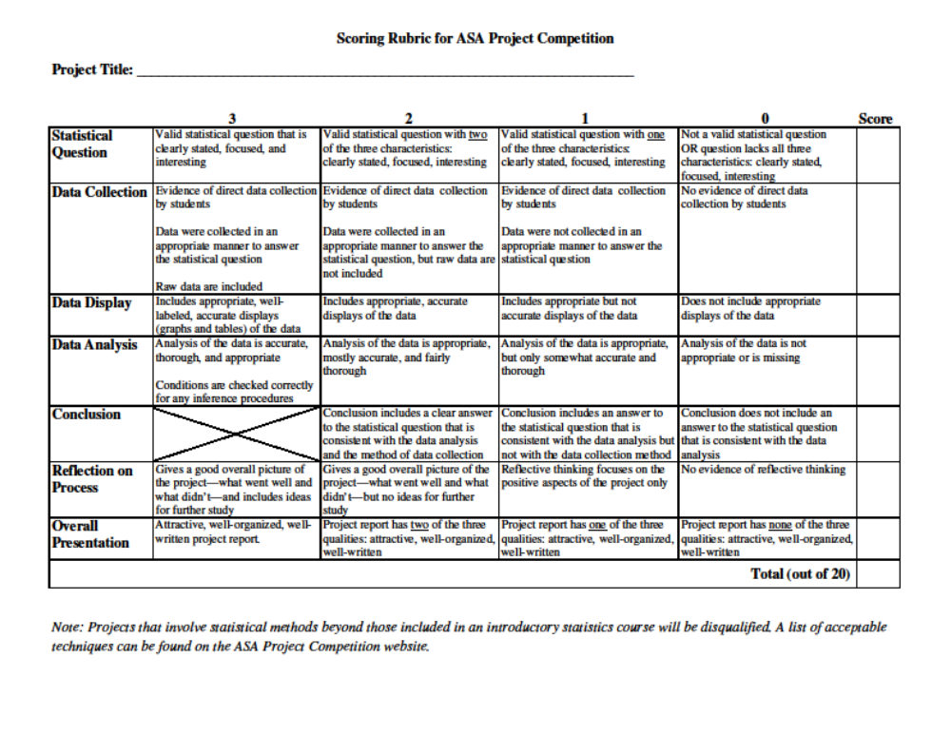Paper

What Is a Statistical Project?
A statistical project is the process of answering a research question using statistical techniques and presenting the work in a written report. The research question may arise from any field of scientific endeavor, such as athletics, advertising, aerodynamics, or nutrition. A project differs from a statistical poster in that a written report is used to present the findings.

Data-Based Problem Solving
The process of developing a statistical project should demonstrate the scientific method and pose a focused question or questions, collect appropriate data, analyze the data thoughtfully, and draw correct conclusions. Because students are asking questions continually about what touches their lives, they should have little trouble generating questions about themselves or their schools, families, neighborhoods, or interesting phenomena in the world. Once a question is proposed, students should examine it. First, is it a question that can be answered? (The question “Is there intelligent life in the universe that does not come from Earth?” is an extremely interesting question, but not one that is likely to be answered in a short-term project.) Second, can students collect data to answer the question or has someone else already collected data that could be used to find the answer? Once the question is chosen, data must be collected. If published data are used, students should understand how the data were obtained and record their source. Usually, students choose to collect their own data. Time should be spent deciding how to collect this data. If a survey is used, how are the people chosen to answer the questionnaire? If two treatments (i.e., models, grades, genders, etc.) are to be compared, how can comparisons be made fairly? How will the data be recorded? After the details have been worked out, students are ready to obtain the data. Great care should be exercised at every stage of data collection. Careless measurement or recording of data cannot be remedied in the analysis phase of a project. Thoughtful analysis of the data may take many forms and should be guided by the question and how the data were collected. Usually, it is best to begin by graphing the data. Can graphs be used to give the answer to the question or questions? Most of the time, graphics have been the sole method of data analysis for grades 4–6. As students gain experience, simple statistical methods such as a chi-squared test or a t-test may be used. Regression has been used occasionally. Sometimes, estimation is most appropriate and hypothesis testing is not needed. Other methods may be used, depending on the question and data. Once analysis is complete, the question should be answered. The data may not be able to provide a conclusive answer. For example, one treatment may appear to be better than another, but the difference was not significant. If the question has a definitive answer, that should be presented. A check should be made at this point to make certain the answer matches the question. It is easy to get caught up in the analysis phase and obtain many answers, none of which addresses the research question. Finally, consider the strengths and weaknesses of the project. What would be changed if the project was done again?

IV. The Individual Written Report
Great latitude may be taken in developing the written report. Each individual student should plan how to communicate their work effectively. The longest report does not necessarily represent the best project. However, the report must accomplish the following:
- Demonstrate how and why the particular topic was chosen.
- Show how the research was conducted as a team and as an individual (if different).
- Delineate what conclusions were obtained and explain any differences between conclusions reached on your individual data compared to the aggregated team data.
- Include the collected data and its analysis both individually and aggregated.
- Discuss the strengths and weaknesses of the selected statistical methods.

A Final Note
The NCTM Standards for Curriculum and Evaluation in School Mathematics presents the vision that problem solving is a main goal of mathematics instruction at all levels and calls for student involvement in statistical activities at all grade levels. The standards indicate statistical thinking should start in the primary grades with the creation of student data from class activities. In upper grades, the emphasis is on collecting, organizing, summarizing, and interpreting data from other school disciplines, such as the physical or social sciences, as well as outside interests of the students. The statistical project is a powerful tool for attaining these goals while exercising essential communication skills.

